LOHIA COLLEGE CHURU
E LECTURES 2019-20
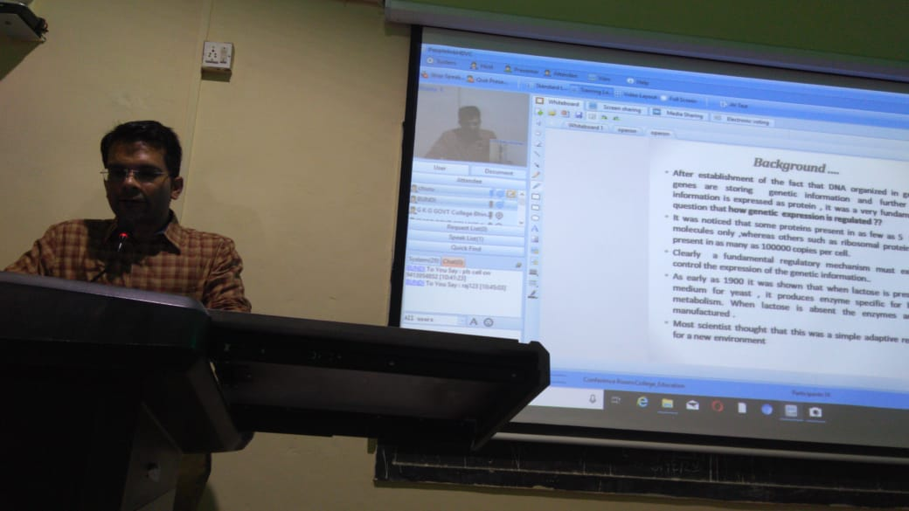
Sh Shantanu Dabi, Assistant Professor, Zoology, delivering e lecture on 19.09.2019

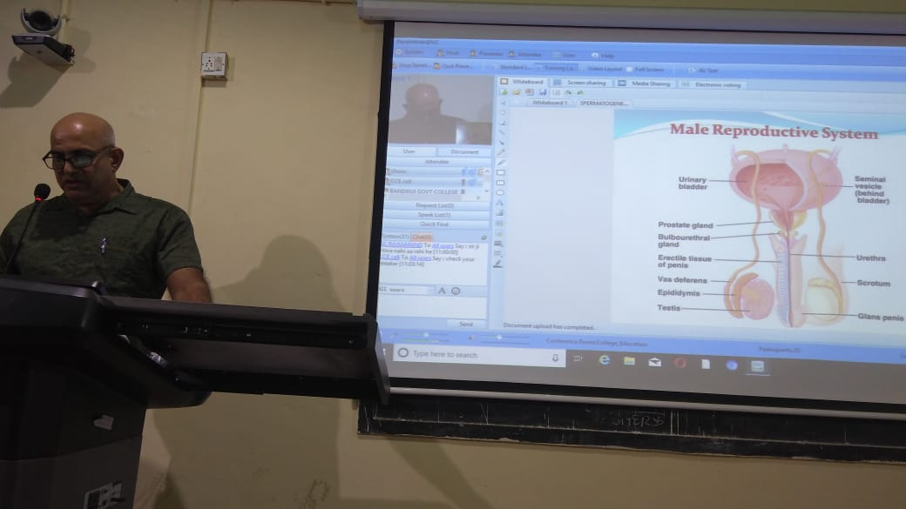
DR K C Soni, Associate Professor, Zoology, delivering lecture on 04.10.2019

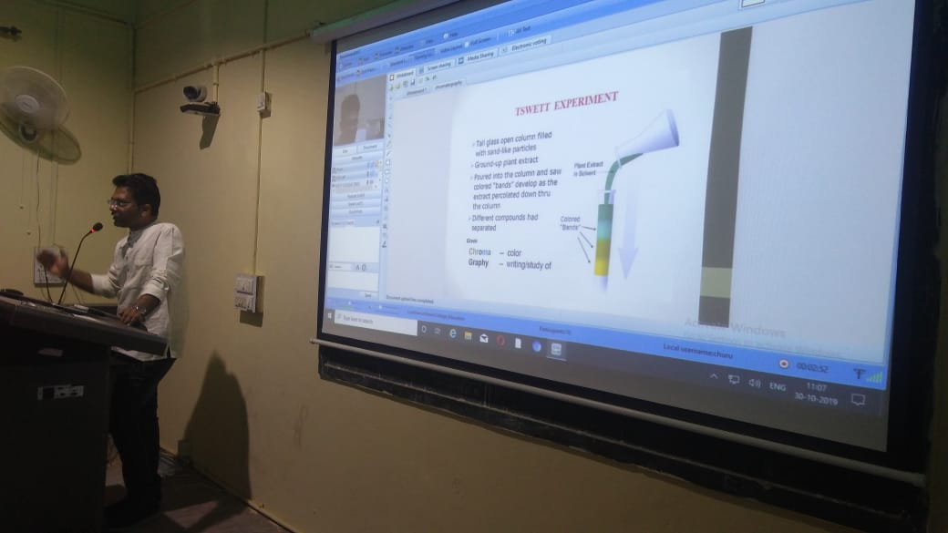
Sh Shantanu Dabi, Assistant Professor, Zoology, delivering e lecture on 30.11.2019

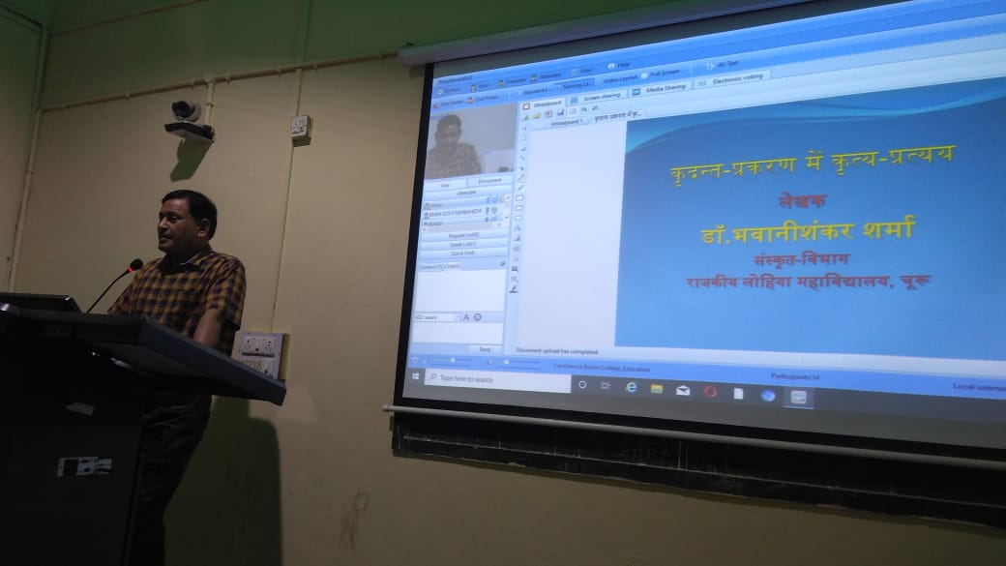
DR B S SHARMA, Associate Professor, Sanskrit, delivering e lecture on 31.10.2019

